How to Photograph Birds in India

While almost anyone will have seen a Crow, how many will know a House Crow from a Large-billed Crow? A House Crow will have a pale nape, neck and breast while the Large-billed Crow will be all black! Both these birds are commonly seen all over India and are known as “Widespread Residents”. Welcome to the world of Birds!

While over 8600 species of birds have been recorded on our planet about 1200+ species of these are found in India. Several field-guides are available to help a beginner identify these birds. (I use the Pocket Guide to the Birds of the Indian Subcontinent by Richard Grimmett, Carol Inskipp and Tim Inskipp) Thus, if you begin to look for these wonderful creatures in nature you will soon notice that they are of different shapes, sizes and colors. They behave and call differently. They are found in different habitats and eat different foods. Some fly very high up in the sky while some cannot fly at all. The only thing common to all birds are that they have feathers and two legs! As you begin noticing details of these lively birds and learn to identify them with the help of the field-guides and fellow birders, you will be known as a “ Bird Watcher ”. Bird watching is one of the most popular hobbies in the world and can bring you great joy.

Very unlike bird watching bird photography is one of the most challenging task any human being can undertake. If you, for the first time decide to go out there in the open and try to photograph birds, chances are you will return completely frustrated and find that those shots that you actually managed to click are worthless. So how does one photograph birds?

A. Setting a goal

Now that you have decided to photograph birds, you need to set yourself a goal. If your goal is to photograph all the birds found in India, one lifetime will certainly not be enough. As many as possible is a more reasonable option. Birds of a certain region, is another good option.

A good bird portrait would mean:

- The bird in sharp focus from beak to tail.
- The bird sitting on a natural perch.
- The bird at your eye level while, you are shooting.
- The sun on your back and on the bird.
- A clear background.

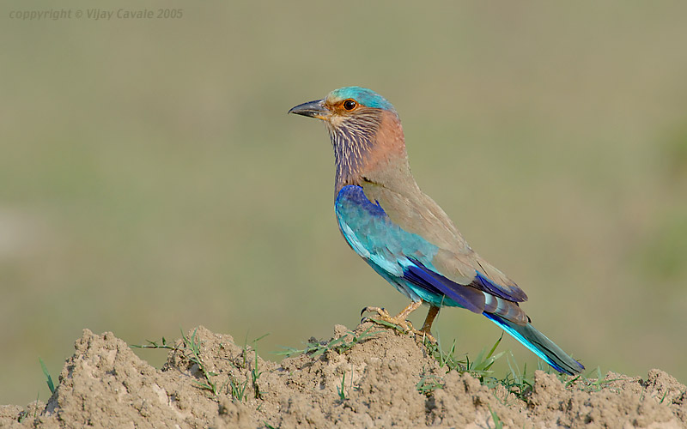

Indian Roller

B. Know Your Subject

It is best that you begin bird photography by knowing a bit about birds. If you spend some time as a “ Bird Watcher ” your “ Bird Photographer ” endeavor will be more fruitful.

While out in the field studying the birds, among other things you will notice the following:

- Apart from a few, most birds disappear on human approach.
- Many a bird’s survival tactic is to remain unnoticed.
- Birds are varied in size. As small as a human thumb to as tall as a human!
- Bird habitats are varied. Some live up, up in the sky and some rarely leave the ground.
- Bird calls are varied. You can soon learn to recognize birds by their call.
- Some Birds nest several times a year. Most birds nest at least once a year.
- If humans interact with the nest in any way, the chances of it being predated doubles.
- Most birds are approachable while they have young to feed.
- Most adult birds give out a distinct alarm call if they sense danger (normal call is different).
- If a bird is carrying feed/nesting material, it usually means it is nesting in the area.
- While some birds have stunning and varied colors, others are plain.
- Male birds are more attractively colored than females in many species.
- Many birds change colors and grow extra feathers while breeding.
- A young bird many a time looks different from the adult.
- While in many species both sexes look alike, in many others the male looks completely different from the female.
- Some birds do not move much, while others rarely stop moving.
- Birds are more active and more vocal during their breeding season.
- Migratory birds obviously, can be seen only during a part of the year, in a region.
- Many birds fly out to feed and roost back at the same place day after day.
- Many birds are nocturnal and are never seen during the day.
- While some birds can be identified easily, in many, every small detail is necessary.
- Bird food is varied. Insects, seeds, fruits, & berries, parts of flower & nectar, rodents, reptiles, fish and other aquatic insects, scorpions & snakes, dead animals…and other birds too!

C. Nest Photography

By this time you would have learnt that the easiest way to photograph a bird is to find its nest. If you visit any “Bird Sanctuary” you will find plenty of birds like Egrets, Herons and Storks nesting on trees near water. The nests will be open (platform) and the parents will come repeatedly to the nest carrying food for the young. A delightful opportunity for any bird photographer and a very good beginning too!

At this point of time, a good bird photographer must understand that while some birds can defend their nests from natural predation, most birds cannot. Several species of birds like Lapwings and Plovers relay entirely on camouflage as a tool to counter natural predation.
For a large number of birds the most venerable time in their life span is while they are inside their nest or have just fledged. There are any numbers of predators these nesting birds have to outwit in order to be successful in raising their young. Mongoose, Monitor Lizards, Snakes, other birds like Crows and Coucals are all constantly looking for a opportunity to predate a nest. The biggest challenge for these predators is to find a nest and the biggest challenge for the bird is to remain unnoticed! A bird photographer unknowingly may provide a clue to these vigilant predators to an easy meal.

It is for this reason that nest photographs are not encouraged by a large number of the audience. It is best to avoid this temptation to go after a venerable nesting bird that allows easy approach and use other techniques to get a successful image. Remember that it is not good practice to put the birds in distress or danger just to get a great image.

D. Learn to outwit them to get into position

Once you have decided not to haunt nesting birds and try for some decent portrait photographs of birds as they go about living their vibrant natural life, your greatest challenge would be to get into the right position to focus and click. This would mean getting as close to the bird as possible while it is sitting on a nice natural perch with the sun shining on it and also your camera and you being at the same level as the bird! Sounds tough? Yes it is!

The challenges are many. The major one, at least in India is that a large number of species of birds are extremely alert to human activity. They will disappear as soon as they spot any unnatural activity like a photographer trying to focus his camera on them!

Once, I saw a group of 20 painted storks sitting in shallow water, in good light, offering a great photo opportunity as I had mostly seen them on trees at their nesting sites. I stopped my car and was contemplating my next move when a woman from the nearby village came with her buffalo and headed for the water. There goes my opportunity I thought as she and her buffalo went right next to the storks. As she began washing her buffalo, the storks did not move even though the woman must have been about 20ft from the group and inside the water. Emboldened, I took my camera and tripod and walked towards the water. The storks, which until then seemed calm, began to seem distressed at the intrusion. Before I could set up my tripod and focus they were gone! They circled high above the water and headed for another location.

Over time and after innumerable such experiences, I began to understand bird behavior a bit that helped me get into position before the bird disappeared. Here are a few points to note:

- Try and shoot from your vehicle

You will be surprised how tolerant birds are to vehicles. If you do not get down and are able to shoot from your vehicle without making much noise, chances are that the bird will offer you a good opportunity to shoot.

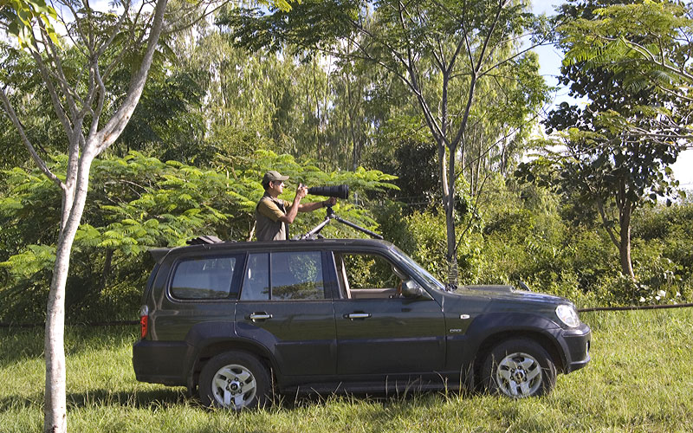

- Try using a Hide

In some cases birds use the same perch regularly. Here you can set up a hide and shoot from inside without scaring the bird. You will be surprised how many species you can shoot if you have the patience to sit in a hide for a day in a probable location. Also, remember to wear dull clothes that merge with the background while in the field.

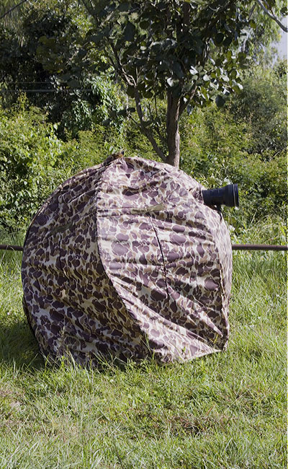

- Food is the key

A large number of species of birds normally feed all day! They have to drink water too. If you wait near a drying out water body, you will notice that as the water level decreases the fish become more accessible to a large variety of birds that feed on them. You will be able to shoot several species around this water body. Kingfishers, Storks, Herons, Egrets, all haunt such water bodies.

Similarly a tree or shrub that offer food like berries and flowers attracts smaller birds like Flowerpeckers and Sunbirds.

In grass patches you will find larks and wagtails feeding on insects. You will find Cattle Egrets and Drongos following grazing cattle as they flush out insects, which the birds pounce on.

Thus, understanding the food habits of different species of birds will help you get into the position for a good portrait shot. Also, remember most birds have a favorite water body where they land to drink water at least once a day.

- Spot the bird before it spots you

Yes it is needless to say that you need to spot the bird to photograph it. However, in case of Raptors and especially Owls, they will be sitting motionless on their favorite roost and most times you will only see them when they move. They move because you are too close and you did not even know it. Thus, watch carefully from a distance to spot a Raptor and act as if you have not noticed the bird and keep approaching it without looking directly at it until you are ready to shoot. As soon as your lens points directly at the Raptor chances are it will fly away. The lesson here is that ignore the watching bird and it will ignore you.

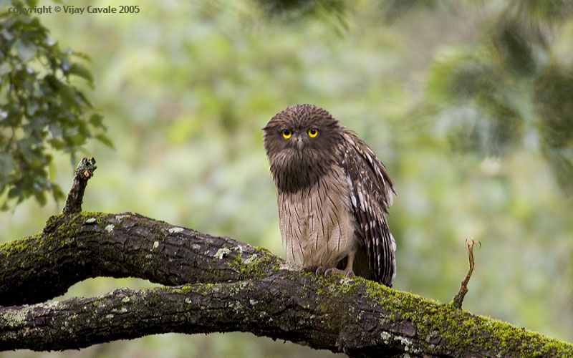
Brown Fish Owl

- Flushing out birds using calls

Sometimes you can play bird call recordings in the field to flush out birds. For example, if you play an Owl call, many birds will begin to mob the “Owl” and thus approach close to the “call machine” providing the photographer with an opportunity. Though I have not used this much, I am told it can be very effective in some difficult cases. However, recording bird calls in itself can bring you great joy.
You can learn more at www.naturesongs.com

E. Do your Homework

Once you are done with the common birds around you, you need to prepare yourself to go after the rare ones. Here there is no alternative to traveling to different parts of the country.
The more time you spend out there, the better!

Some birds migrate while some stay at the same place all through the year. What you need to understand is where to find which bird. For example, the Sarus Crane a magnificent bird that stands as tall as a human is easily found in some parts of North India, while it is not found in South India. Birds are classified as “Widespread Residents”, “Winter Visitors”, “Endemi ” and so on. A large amount of data is available in the form of field-guides, check-lists and web-resource, on the distribution of birds found in India. Nine out of Ten times I have been able to shoot rare birds that are found in one area. For example, I shot the Indian Bustard at Nannaj near Solapur in Maharashtra. The MacQueens Bustard at the Little Rann of Kutch in Gujarat. The Lesser Florican at Sailana in Madhya Pradesh, the Bristled Grassbird in Van Vihar National Park, Bhopal and the Sri Lanka Frogmouth at Anamalais, Tamilnadu.

So, if you learn where to find a rare bird you are more or less sure that it is there for you to shoot. However, you will need some local help and support to locate the bird.

Another surprising factor is that the same species of bird behaves differently at different locations. You can break your neck trying go after a particular species of bird in one area and in another the same species will give you a great opportunity without you even having to move. A typical example is the Rufous Treepie. In most parts of South India this is a shy bird which moves up on the tree branches while at Ranthambore , I saw them sitting on my vehicle steering wheel !

F. Understand habitats and focus your effort

If you have a small garden in your house that has a flowering creeper, you will notice sunbirds visit the flowers regularly to feed giving you great opportunities to shoot them. You can shoot over fifty species of birds in most urban habitats. Bulbuls, Sunbirds, Mynas, Crows, Swallows, Kites, Owls are typical examples.

If you drive a bit outside any city you will find agricultural habitat. Here you will find lakes, paddy fields and grasslands. A large number of species of birds reside in these areas. Weavers, Larks, Egrets, Herons, Bushchats, Robins, Kingfishers are typical examples.

Thus, you will encounter birds in every type of habitat from the deserts to the wetlands and from the crowded cities to the Himalayan peaks. The Shrub Jungles, thick forests, grasslands and sholas all offer unique opportunities and challenges. For example if you enter the shola you will be stepping on leaches on each step you take and there on a branch in almost darkness will be sitting the Oriental Bay Owl ! The grasslands more often then not will have ticks but then they have a large variety of birds like the Zitting Cisticola and the Bristled Grassbird!

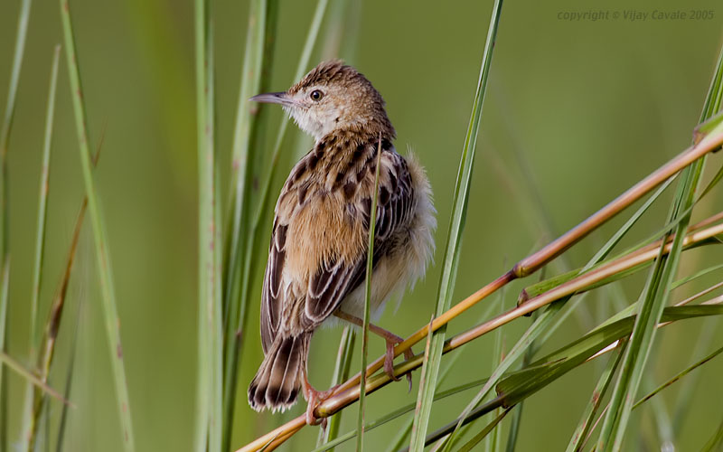
Zitting Cisticola

Very well know bird habitats are mostly areas where “water birds” thrive. These bird sanctuaries soon become major tourist attractions. Keoladeo Ghana National Park, Bharatpur is the most famous for water birds, many of them migratory. In this area you can shoot a hundred species of birds in about a weeks time!

Also, there is no point venturing out in monsoon months on long journeys when you are sure to get rained out or sit at home in the winter months when most parts of India will be full of winter visitors. Remember, in some parts of India it never stops raining while in other parts it never rains!

The point is if you know where you are headed and for what and when, you can be well prepared to face the challenges.

G. Network with like minds

Like I said, bird watching is a very popular hobby. Almost every state in India will have a local bird watching group. Today, egroups are also very popular and you can find very useful data about birds in a particular region from these groups. Several individual websites also offer a great deal of information on birds found in India. You will be surprised at how soon you will be able to connect with helpful birders form a region you plan to visit. It is not uncommon to see small groups of bird photographer traveling about together photographing birds and having fun over the weekend.

Do take a look at www.orientalbirdimages.org to see and enjoy the work of over 400 Bird Photographers from across the globe. Over 14,000 images!!

www.indianaturewatch.net is another great place to network with like minds.

H. Use Technology

The most exciting thing for any photographer today (October ,2005!) is the advance in technology. Digital Cameras offer so much flexibility that all you need to do is get into position and shoot. If you get the focus right, there are a large number of options for the Digital Shooter to “Post Process” his images.

For Bird Photography the apt lens would be a 600 mm , auto focus, telephoto. Combine this with any of the latest Digital SLRs and you will have a winning combination. You can of course do with a smaller lens especially if you are after flight and action shots. Many of the lenses on offer today have Vibration Resistant technology which absorbs the slight shake that happens on hand held shots.

I must say here that if you can afford it please do go for the best that money can buy in terms of equipment. As so much effort goes into getting into position to shoot there is no point using substandard equipment. Internet is you best friend in helping you to find the right set of equipment. For example, www.dpreview.com is an excellent website that provides you with every bit of latest information for you to make the right decision based on your needs. www.timgrey.com is a good place to understand “Post Processing” technique ( not a topic in this discussion)

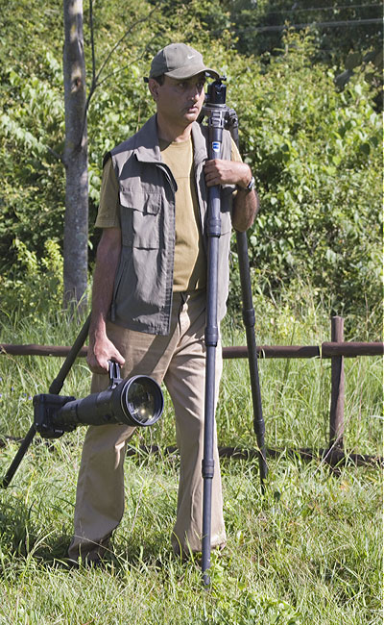

You will need an auto focus lens as there will not be enough time to focus and shoot many of the smaller birds that always keep moving. You will need a Telephoto Lens as most birds do not allow you to get too close.

I use the following equipment for shooting birds in the field :

- Nikon D2X, SLR Digital Camera (12.4 Megapixles, 5 fps/NEF)
- Nikkor AF-S Nikkor 600mm f/4D IF-ED II (Autofocus Telephoto Lens)
- Nikkor 20-70 Zoom Lens (for habitat shots)
- Nikon AF-S Teleconverter TC-17E II

Never use a Telephoto Lens without a good Tripod . I use a Gitzo 1548 Carbon Fiber Tripod with an Arca Swiss Monoball Head.

Digital Film is another not so easy decision as there are so many choices. I use a Lexar 2GB, 80X CFC (Compact Flash Card). Each card can hold 99 RAW (NEF) images shot using the Nikon D2X. I always carry three of these.

I carry a 80GB portable Hard Disk called FlashTrax. If all my CFC’s are full I transfer the images into this Hard Disk and carry on after reformatting the CFC’s.

I always carry multiple batteries for both my Camera and my portable Hard Disk along with their chargers.

Lastly I carry an inverter that can power my battery chargers from my car.

I.Some India Specific issues

India is a glorious and unique country of over a Billion people. Most times if you plan well you will have a pleasant experience though I can confidently say that no two experiences will be the same even if you follow in the foot steps of another.

A few points to note:

- The weather can be unpredictable. Even if you plan well you may get rained out.
- Always be careful with your equipment. Avoid traveling alone if possible.
- Always carry spare batteries and film. Power cuts or No Power are normal.
- In any Indian forest you will need permits to enter and you need to pay camera charges.
- In most forests you are not allowed to get down from your vehicle.
- Elephants are the most dangerous threat in some Indian forests.
- Do watch out for Mosquitoes, leaches and ticks depending on what habitat you are shooting in.
- Do carry all possible basic medicine.
- Follow good food and drink hygiene.
- Find and Follow all rules.

J. Conclusion

Though the obstacles and challenges are many, when you get a good bird portrait comparable with the best in the world, the joy you feel from within will be well worth it. Better still if you want to share your work via egroups, websites, books, presentations or exhibitions. Wonder if you know that very good few images of the 1200+ species of birds found in India actually exist!

There is joy in nature, let us share this Joy!

About the author:

Vijay Cavale has been a nature addict since birth. After almost two decades of a successful career in the Indian IT Industry, at the age of 40 he decided to quit his corporate life and follow his dream. For the last five years Vijay Cavale has been traveling to several parts of India photographing its rich wildlife with focus on birds. He has photographed over 360 species of birds found in India. You can see all of them at www.indiabirds.com All his work in this area is non-commercial and is aimed at creating awareness and sharing the joy.

Vijay Cavale, October 2005.

